Hyper Max Store — Snacks and Chips Database Manual
Combined Technical and User Documentation
Prepared by: Khaled Date: 2026 Version: 1.0

Table of Contents
Part A Technical Documentation
- System Overview
- System Requirements
- Database Structure
- Tables and Columns
- Relationships
- Security
- Maintenance Procedures
- Troubleshooting
Part B User Documentation 9. Getting Started 10. Logging In 11. Adding a New Product 12. Updating a Product 13. Deleting a Product 14. Viewing Reports 15. Closing the Application
Part C System Diagrams 16. Data Flow Diagram (DFD) 17. System Flowcharts

PART A TECHNICAL DOCUMENTATION
1. System Overview
The Hyper Max Store Snacks and Chips Module is a relational database system that manages products, suppliers, categories, customers, and sales transactions. The system was built using Microsoft SQL Server for the back-end database and Microsoft Visual Studio Windows Forms (C#) for the front-end interface. It replaces the manual spreadsheet method used before making daily store work faster and more reliable.
Purpose: Store and manage product, customer, and sales data for the Snacks and Chips department.
Target users: Store Managers (full access) and Cashiers (limited access).
Key features:
- 6 normalized tables connected by primary and foreign keys
- Full CRUD operations through Windows Forms application
- SQL queries with JOIN for reports
- User role-based security
- Data validation through constraints

2. System Requirements
Item | Requirement
Operating System | Windows 10 or 11
Database | Microsoft SQL Server 2019 or higher
Tools | SQL Server Management Studio, Visual Studio 2022
Framework | .NET Framework 4.7.2 or higher
RAM | 4 GB minimum
Disk Space | 500 MB free
Screen | 1280×720 or higher

3. Database Structure
The database is named HyperMax_Snacks_And_Chips_Module and contains 6 tables connected through primary and foreign keys.
Table | Purpose
Category | Stores product categories
Supplier | Stores supplier names
Product | Stores product details (FK to Category and Supplier)
Customer | Stores customer info with contact details
Basket | Stores sale transactions
BasketItem | Stores items in each basket (junction table)

4. Tables and Columns
Category:
Column | Type | Constraint
Category_ID | INT | PRIMARY KEY, IDENTITY
Category_Name | VARCHAR(50) | NOT NULL
Supplier:
Column | Type | Constraint
Supplier_ID | INT | PRIMARY KEY, IDENTITY
Supplier_Name | VARCHAR(100) | NOT NULL
Product:
Column | Type | Constraint
Product_ID | INT | PRIMARY KEY, IDENTITY
Product_Name | VARCHAR(100) | NOT NULL
Price | DECIMAL(10,2) | CHECK > 0
Quantity_in_stock | INT | CHECK >= 0
Size | VARCHAR(30)
Expiry_Date | DATE
Category_ID | INT | FOREIGN KEY
Supplier_ID | INT | FOREIGN KEY
Customer:
Column | Type | Constraint
Customer_ID | INT | PRIMARY KEY, IDENTITY
Customer_Name | VARCHAR(100) | NOT NULL
Phone | VARCHAR(20)
Email | VARCHAR(100)
Address | VARCHAR(200)
Basket:
Column | Type | Constraint
Basket_ID | INT | PRIMARY KEY, IDENTITY
Basket_Date | DATE | NOT NULL
Customer_ID | INT | FOREIGN KEY
BasketItem:
Column | Type | Constraint
BasketItem_ID | INT | PRIMARY KEY, IDENTITY
Basket_ID | INT | FOREIGN KEY
Product_ID | INT | FOREIGN KEY
Quantity | INT | CHECK > 0
Unit_Price | DECIMAL(10,2)
Total_Amount | DECIMAL(10,2)

5. Relationships
Relationship | Type
Category, Product | 1:M
Supplier, Product | 1:M
Customer, Basket | 1:M
Basket, BasketItem | 1:M
Product, BasketItem | 1:M
Customer, Product (through Basket and BasketItem) | M:N

6. Security
User roles and permissions:
Role | Username | Password | Access Level
Store Manager | StoreManager | HyperMax2026! | Full CRUD on all tables
Cashier | Cashier | Cashier2026! | Read products/customers, Insert baskets only
GRANT and REVOKE commands control the permissions.

7. Maintenance Procedures
Procedure | Frequency | Purpose
Backup database | Daily | Protect data from loss
Check data integrity | Weekly | Verify FK and constraints
Update statistics | Weekly | Keep queries fast
Review user permissions | Monthly | Maintain security

8. Troubleshooting
Problem | Solution
Cannot connect to database | Check SQL Server service is running
Application crashes on Save | Make sure all required fields are filled
Login fails | Verify username and password are correct
Foreign key error | Make sure related records exist first
Database does not exist error | Verify database name is correct

PART B — USER DOCUMENTATION
9. Getting Started
Step 1: Find the Hyper Max application icon on the desktop.
Step 2: Double-click the icon to open the application.
Step 3: The Login screen will appear.
10. Logging In
- Type your username in the Username field
- Type your password in the Password field
- Click the Login button
(Figure: Login screen with credentials)
If your details are correct you will see the main screen. If not you will see an error message.
(Figure: Successful login as StoreManager)
(Figure: Error message for wrong password)

11. Adding a New Product
Step 1: Type the product name (example: Lays Classic)
Step 2: Type the price in JD (example: 0.75)
Step 3: Type the quantity in stock (example: 120)
Step 4: Type the size (example: 150g)
Step 5: Choose the expiry date
Step 6: Select the category from the dropdown
Step 7: Select the supplier from the dropdown
Step 8: Click Save
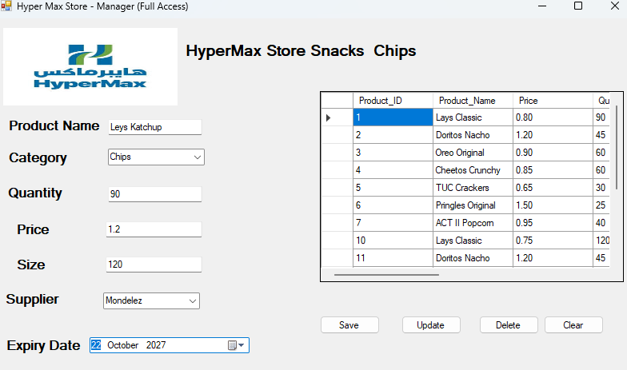
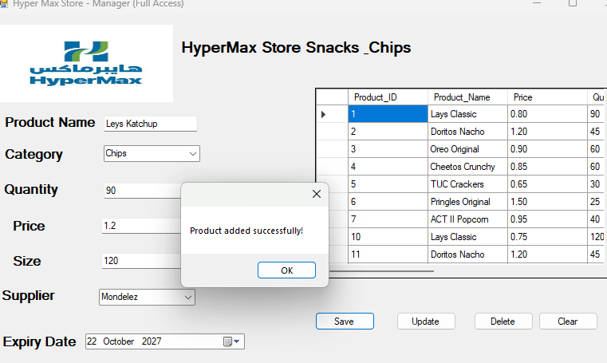
12. Updating a Product
Step 1: Click on the product row in the grid (the fields fill automatically)
Step 2: Change any field
Step 3: Click Update
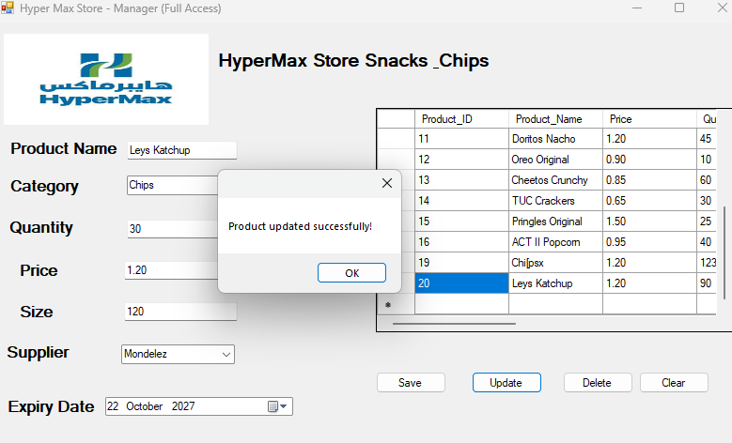
13. Deleting a Product
Step 1: Click on the product row you want to delete
Step 2: Click Delete
Warning: Deleted products cannot be recovered easily.
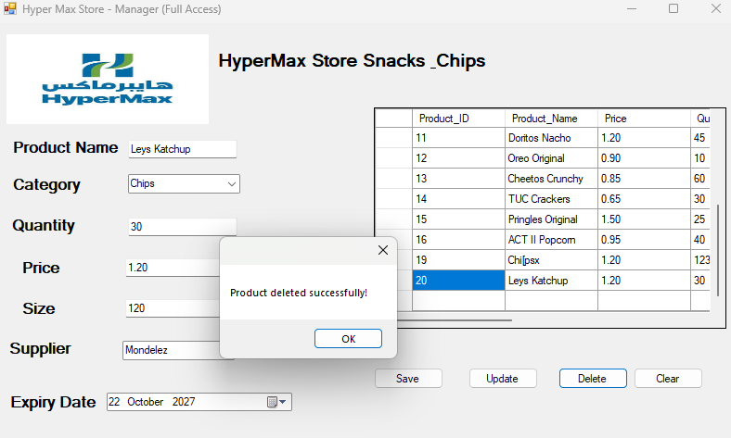
14. Viewing Reports
The DataGridView at the bottom always shows all products with category and supplier names. Other reports are generated using SQL queries:
- All products with categories and suppliers
- Low stock products (quantity below 20)
- Full sales report with customer details
- Total spending per customer
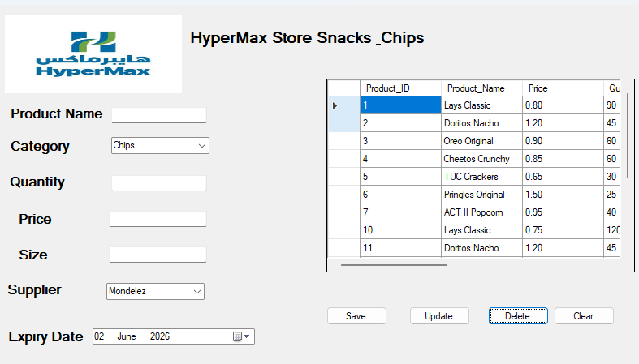

15. Closing the Application
Close the application by clicking the X at the top-right corner. Your data stays safe in SQL Server.

PART C SYSTEM DIAGRAMS
16. Data Flow Diagram (DFD)
The DFD shows how data moves through the Hyper Max system.
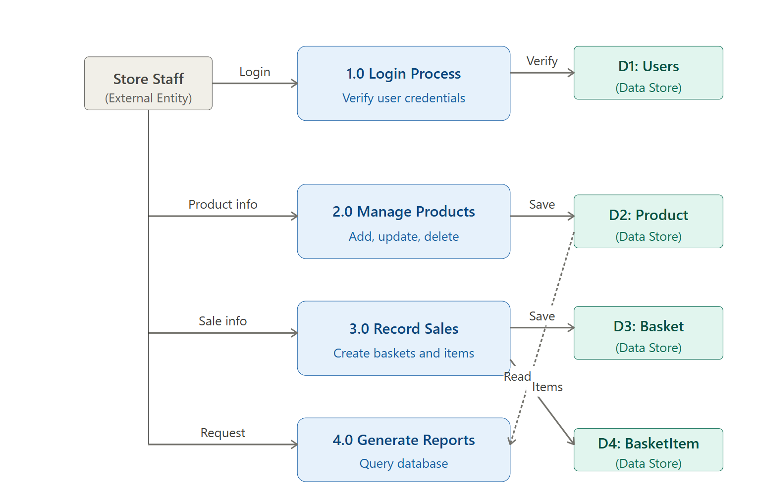
Process flow:
- Staff enters product details through the application form
- The application sends the data to SQL Server using the connection string
- SQL Server validates the data with constraints (NOT NULL, CHECK, FOREIGN KEY)
- Valid data is stored in the database tables
- When reports are requested, the application sends a SELECT query
- SQL Server returns the matching data
- The application displays results in the DataGridView

17. System Flowcharts
The flowcharts show the step-by-step processes for the main operations.
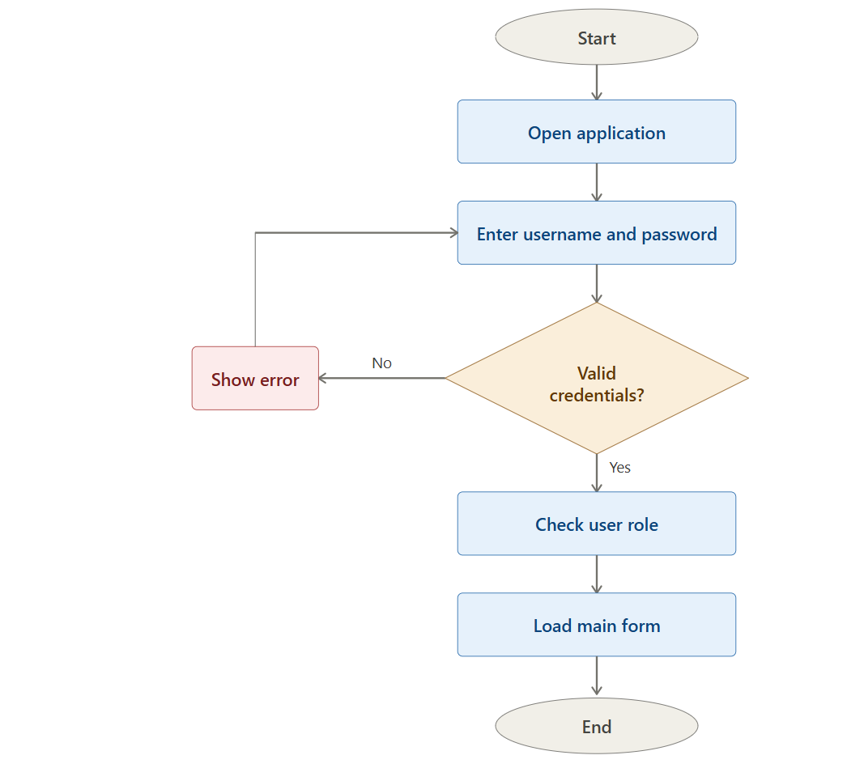
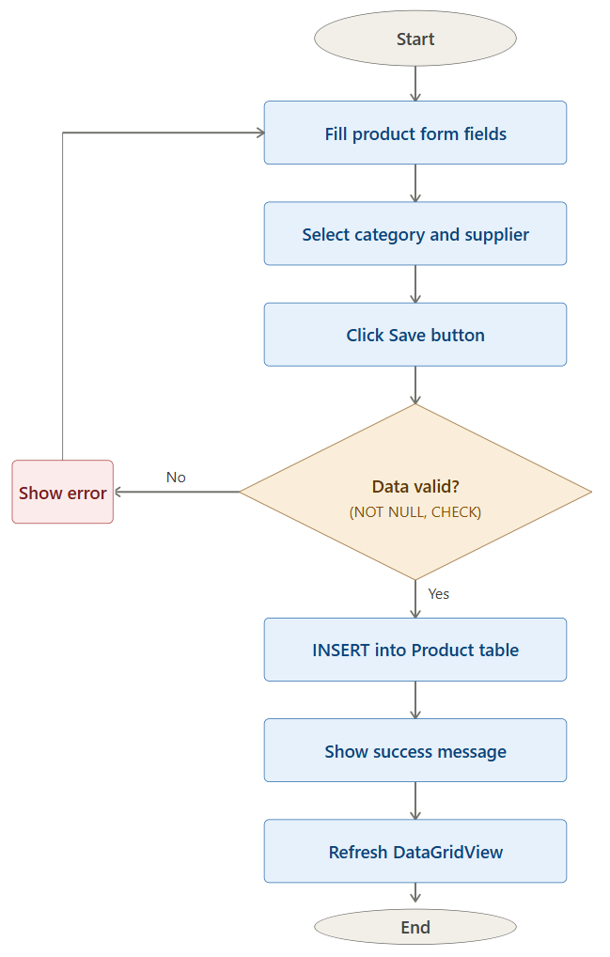
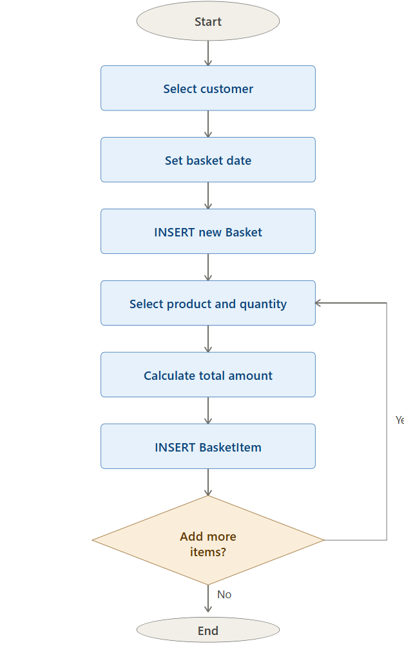
End of Manual

